Pulmonary Stenosis
Pulmonary valve stenosis results from fusion of the leaflets. In adults the cusps may be calcified. When the valve is very thick but there is no fusion of the cusps the valve is sometimes described as dysplastic. PS is the most common form of right heart obstruction and occurs in 7-10% of patients with congenital heart disease. Functionally – the obstruction causes an increase in RV pressure. RV output is maintained by the development of RV hypertrophy, which can sustain a large pressure gradient for many years without symptoms. RV dilatation and RV dysfunction can also occur in the unoperated adult population.
Pulmonary stenosis is commonly an isolated anomaly, but associated defects include ASD and peripheral pulmonary artery stenosis.
Pulmonary stenosis is associated with genetic or chromosomal abnormalities; the most common are Noonan’s, William’s and Alagille syndromes.
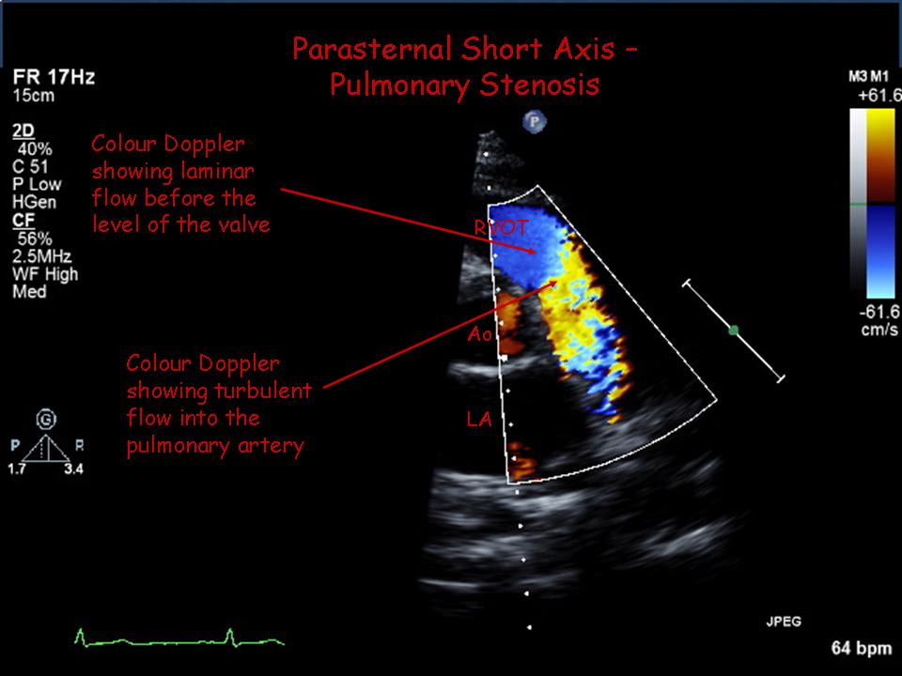

2D Echo / Colour Doppler
Assess valve for thickening, calcification, doming
Turbulence on CFM Doppler – level of flow acceleration (sub-valvar/valvar/supra-valvar)
Assess RV hypertrophy, in particular in the infundibular region, which contributes to obstruction (see Doppler image)
Size of the pulmonary arteries
RV dilatation and RV dysfunction (TAPSE may be helpful)
PR and TR severity
Is the atrial septum intact? right to left shunting through a PFO / ASD

Doppler Measurements
Peak velocity across the pulmonary outflow to estimate peak PG – Bernoulli equation 4V²- most centres use peak PG rather than mean PG.
(Trivial < 25mmHg, mild 25-49mmHg, moderate 50-70mmHg, severe > 80mmHg) – use multiple views parasternal and sub-costal also utilize the non-imaging transducer

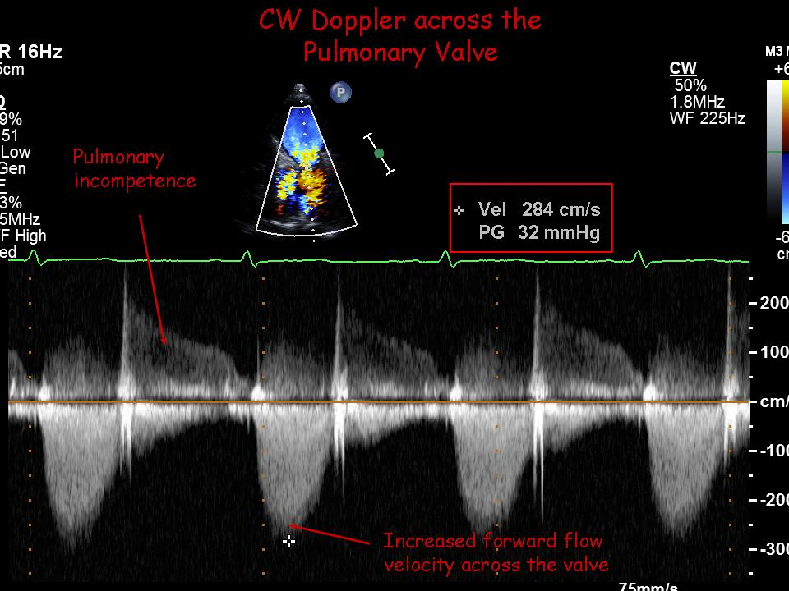

Common Pitfalls/Limitations
TR jet peak velocity estimates RVSP and therefore does not represent PA systolic pressure in the presence of PS
TR jet cannot be used to estimate PA systolic pressure as the PS has to be considered – the TR can only estimate the RVSP
When obstruction is discrete and confined to one level it is OK to use modified Bernoulli equation, however if there a long segment of stenosis and dynamic obstruction as seen with infundibular hypertrophy, it is difficult to evaluate by CW Doppler and cardiac catheterization may be required.

