Ventricular Septal Defects

Ventricular septal defects (VSDs) can be many different shapes, sizes and in different and sometimes multiple locations. If the defect is small there is a large pressure gradient between the ventricles and so blood flows at high velocity from left to right ventricle, this is termed a restrictive defect. If the defect is large with a low pressure gradient between the ventricles, this is termed an unrestrictive VSD. This type of VSD can lead to Eisenmengers syndrome.
The two most common types of restrictive VSDs are perimembranous (accounting for approximately 75% of lesions) and muscular defects. Rarely, defects are seen in the sub-pulmonary area, these are termed doubly-committed or juxta-arterial defects.
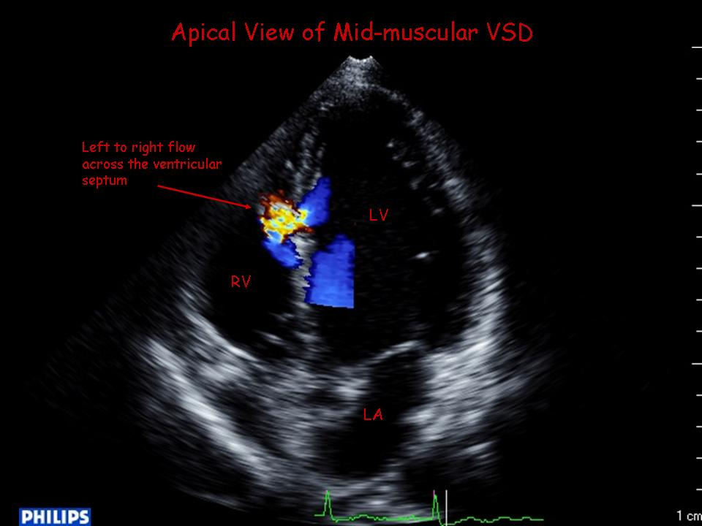

2D Echo / Colour Doppler
Number and location of defect(s) – ensure the septum is fully assessed from multiple views
Left (not right) ventricular dimensions and function for evidence of dilatation and volume loading (hyperdynamic function)
Presence/degree of aortic regurgitation
Presence/degree of tricuspid regurgitation

Doppler Measurements
Peak VSD jet velocity to estimate the pressure difference between LV & RV and in turn assess the presence/absence of pulmonary hypertension. A high jet velocity with normal systemic BP indicates low/normal right ventricular systolic pressure.
Systemic systolic BP – 4V_{VSD}² = RV systolic pressure
Tricuspid regurgitation peak velocity can also be used to assess RV systolic pressure (if unable to align to the VSD jet), however, be cautious of VSD jets which are directed towards the TV and may be misinterpreted as a high velocity TR jet.
Stand alone CW Doppler may be useful to accurately align with the VSD jet.

Common Pitfalls/Limitations
The right heart will not dilate with a restrictive VSD – the shunt occurs during systole and therefore blood does not pool in the RV, instead pulmonary blood flow is increased and in turn there is increased pulmonary venous return leading to left atrial and left ventricular dilatation.
Defects may close spontaneously with time; just because it was there last year does not mean it will be there this year! If in doubt, obtain a clinical opinion of whether there is a VSD murmur.
Some small muscular defects may close during systole, making evaluation of the peak velocity difficult, again a clinical opinion may be valuable.
Qp:Qs shunt estimation on echo is nota reliable/reproducible measurement
Always check for co-existing lesions

