Congenitally Corrected Transposition of the Great Arteries
Congenitally corrected TGA is the condition in which the atria are in the normal position (atrial situs solitus), and receive the appropriate venous return however there is double discordance, in that the atria are connected to the opposite (‘wrong’) ventricle (LA to RV, RA to LV) and the ventricles are connected to the ‘wrong’ great artery (RV to Aorta, LV to PA). This results in a morphological right ventricle supporting the systemic circulation and the morphological left ventricle supporting the pulmonary circulation. The aorta lies in a leftward position relative to the PA.
The heart postion in the chest is usually normal (levocardia) or midline (mesocardia), but in 20% it is right sided (dextrocardia).
Associated lesions are most commonly VSD, PS (more appropriately LVOTO) or pulmonary atresia, and tricuspid valve abnormalities.
2D Echo / Colour Doppler
Expect unconventional images from a ‘normal’ parasternal window
To identify ventricular morphology look for evidence of RV moderator band, trabeculations and apical offset of the tricuspid valve annulus (best assessed from an apical 4-chamber view). The LV has papillary muscles, smooth walls and the mitral annulus is further from the apex.
Visually assess systemic ventricular function and relative size (compared to pulmonic ventricle)
The great arteries do not have a normal ‘cross-over’ relationship – identify the pulmonary artery by evidence of bifurcation and the aorta by it’s arch giving rise to head and neck vessels.
Assess severity of AV valve regurgitation – particularly the systemic AV valve (tricuspid valve)
Look for evidence of a VSD
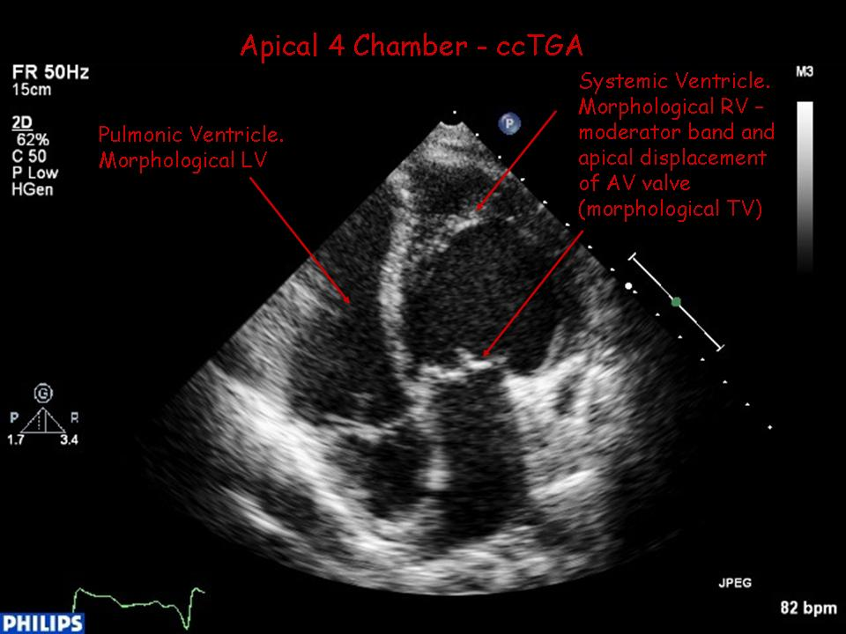

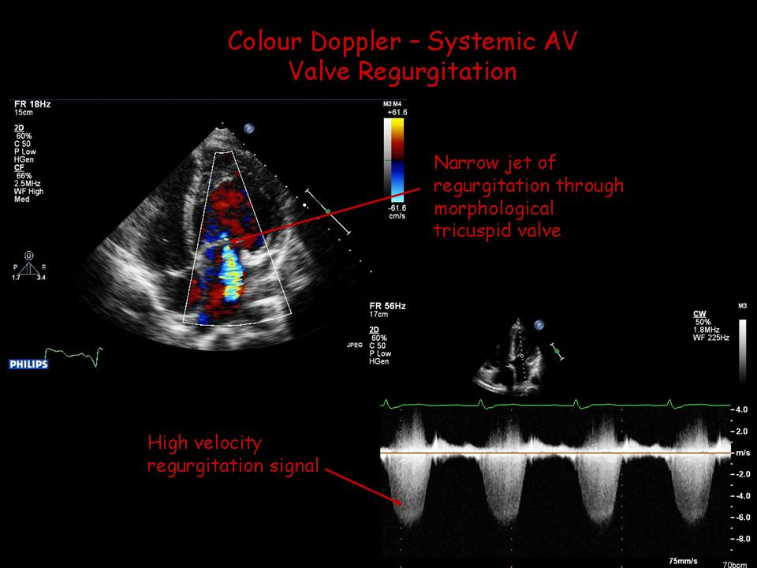
Doppler Measurements
Use PW & CW Doppler in the outflow tracts – the abnormal relationship can make them difficult to differentiate. It’s important to establish whether there is any pulmonary stenosis.
Peak velocity of AV valve regurgitation – expect a high velocity signal across the systemic AV valve (tricuspid valve)

Common Pitfalls/Limitations
Very unusual parasternal imaging – it oftens help to begin with apical imaging
Nomenclature can often be confusing – when reporting refer to the systemic ventricle/AV valve and the pulmonary ventricle/sub-pulmonary AV valve.

